1.
Vasicek model:
For [5.9, 0.2, 0.3, 0.1]:
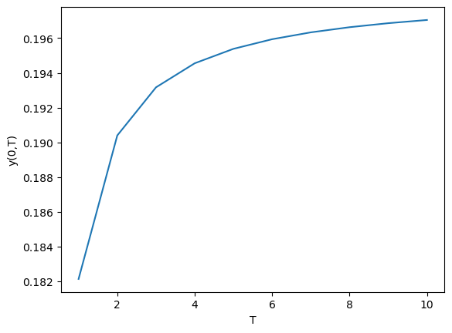

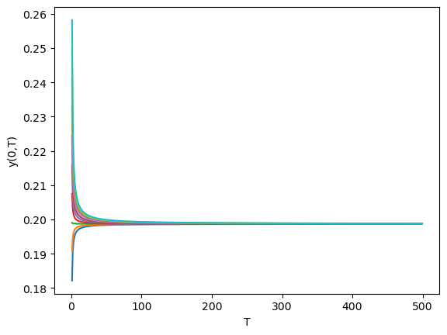

For [3.9, 0.1, 0.3, 0.2]:

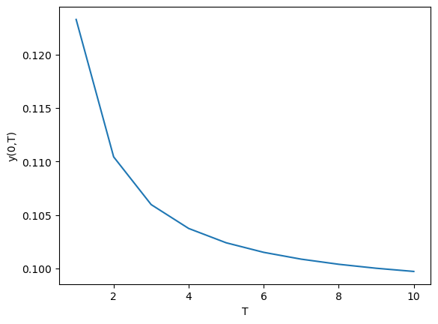

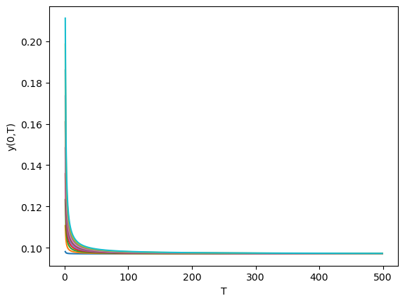

For [0.1, 0.4, 0.11, 0.1]:
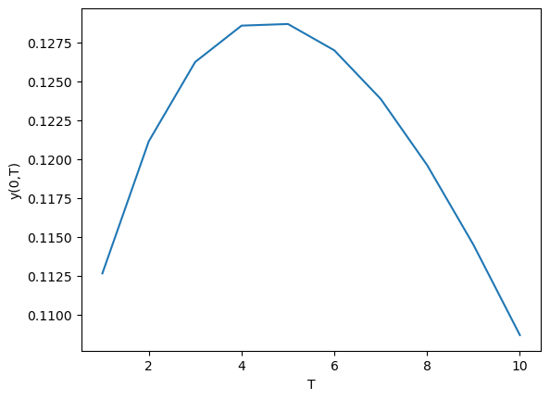

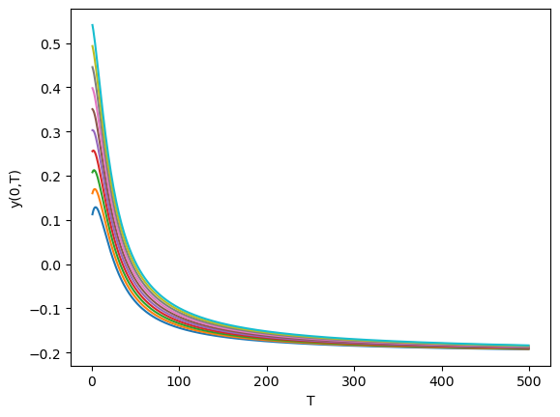

2.CIR Model:
For [0.02, 0.7, 0.02, 0.1]:

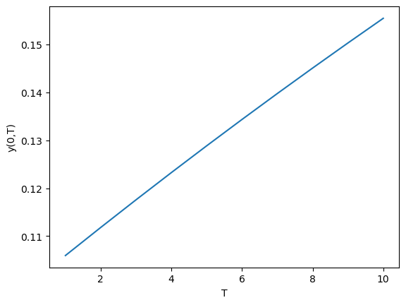

For [0.7, 0.1, 0.3, 0.2]:
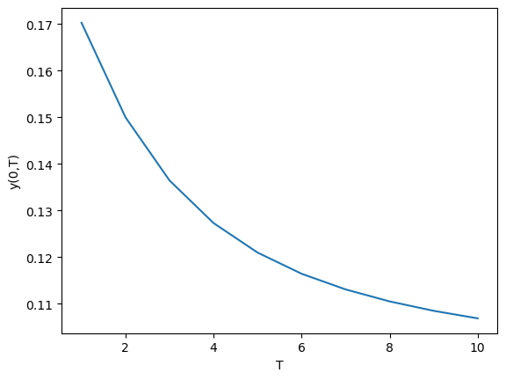

For [0.06, 0.09, 0.5, 0.02]:
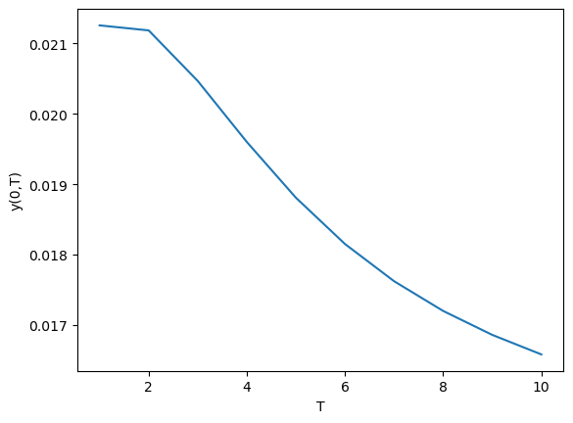

For [β, μ, σ]=[0.02, 0.7, 0.02] and r(0) = 0.1 : 0.1 : 1

